Lab: Add a New Host to the Cluster

Objective: | Add an additional node to a cluster.
Successful Outcome: | hadoop-slave will be added to your Hadoop cluster as a DataNode.
Before You Begin: | Your 3-node cluster should have Hadoop successfully installed.

NOTE: this lab includes RESIZE of Hadoop Docker clusters

- Login to Ambari
  - If you are not logged in already, login to the Ambari Dashboard of your cluster at [localhost]:8080.
- Run the Add Hosts Wizard
  - Click on the Hosts tab of Ambari.
  - Click on the Action Dropdown and choose Add New Hosts option to start the Add Host Wizard:
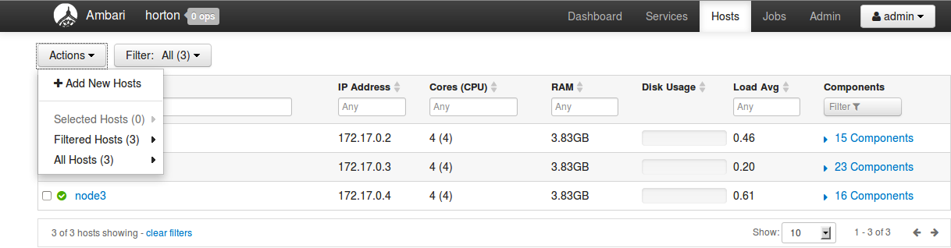
- Complete the Add Host Wizard
  - You have seen this wizard before when you installed HDP, so we will provide only a few hints in this lab. Read through the following hints before running the wizard.
  - The hostname of the node you are adding is hadoop-slave(x), where (x) is 3-5.
  - On the Assign Slaves and Clients step, choose only the Client option.
- Verify the New Host
  - Go to the Hosts page of Ambari. You should see all four of your nodes now listed.

RESULT: You have added a new node to the cluster and Hadoop is installed on it. In a later lab, you will commission this node as a DataNode.

